Preston Rollins, Everton Correa, Anthony Martini

uRate Rating System and Organizing Tool

Idea Proposal & Research

Pace University Fall 2014

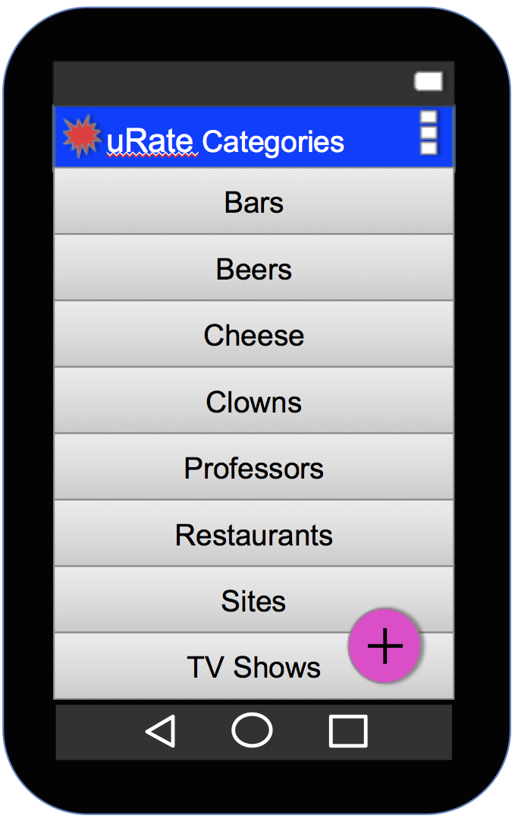

1. *What is/are the problem/s you want to solve?* 
   1. There is not an app that allows rapid user defined categorization of places and things for ratings and notes. Most rating apps are targeted to a narrow category. Apps that target broader categories have too many ratings to wade through and don’t make it easy for users to search their own ratings.
   2. New rating system that is easy to understand, concise and complete. Simple note taking, other apps are not as good for remembering things that people say by date and time, restaurants you would recommend or not to your friends. Many are the times where we find ourselves reaching for a napkin or putting a note to ourselves embedded in a text message to whoever you were speaking to leading to lost ideas all over in your phone.
2. *Who are the users you are targeting?* 
   1. Freddy works downtown and is always on social networking using his Android. He loves to go out and try new beers at local bars. He is looking for an app that will allow him to track which bars he has visited and what beers he has tried, as well as keep notes on them and rate whether he would go back.
   2. Jennifer lives in an apartment on the UWS and is always playing host to friends visiting the city. While living in the city she has come across some unique sites. She would like an app that would allow her to keep track of places she can take visitors and show them on a map.
3. *How will this solution solve the tackled problem/s? Please provide a vision statement of the solution.*

The app allows users to create their own categories to track and rate what they want. It allows them to take notes on things of interest. It only displays what they enter so they can rapidly access the things they have rated. They can search by category or find places nearby that they have entered. And the app allows them to do all this quickly so they don’t waste time in their phone when they want enjoy what they are tracking.

1. *What is your 140-character pitch for this solution?*

New rating system that is easy to understand, concise, and complete. Simple not taking on places and things you would recommend to your friends…or not.

1. *What are the major features of the solution? List the features.*
   1. Ability to take notes on places/things
   2. Ability to track location
   3. Ability to create custom categories and add places/things
   4. Ability to access and make complete thoughts.
   5. Ability to access in Multi-Language Support
   6. Ability to access camera
2. *How is this solution unique? How does it relate to existing solutions on the market? What are 5 solutions similar or related to what* 
   1. Major apps like Yelp! have more categories to choose from but do not allow users to define their own categories. Also, while Yelp! has a bookmark feature it is not searchable by category and does not readily show the user’s rating or comments. Finally, most apps don’t make it simple to add and rate new things and then track your own reviews. They require too much time to sort through all other user ratings.
3. *What are the risks associated with the development of this solution? Why wouldn’t it be delivered completely, on time and on budget? Identify 4 to 6 risks that are relevant in your case.*

Lack of funding.

Competition and visibility.

Slow in trends of eating out. Security issues.

No way to receive user satisfaction in real time.

1. *What technologies, APIs etc will you be using to develop this solution? Provide links and explanations.*

**APIs**

* Level 14 from the Java SDK.
* External API’s to be determined
* Google API’s.
* SQL Lite
* Camera API

**External References**

* ([GitHub](https://github.com/evertoncorrea88/uRate)) This will be used for synchronized efforts and version control
* ([Youtube](https://www.youtube.com/watch?v=ugWu3gyte4I&list=PLGLfVvz_LVvSKgnFm8-6Fz1cd6zt_KxTC&index=1)) Easy to follow tutorials to get our knowledge and skills up to par
* ([developer.android.com](https://developer.android.com/tools/support-library/setup.html)) The programmers would do best to implement this API